Lab no 6 & 7

Task no 01:
- Use AND instruction to convert lower-case characters to upper-case characters. Hint:
'a' = 0 1 1 0 0 0 0 1 'b' = 0 1 1 0 0 0 1 0 lower-case characters
'A' = 0 1 0 0 0 0 0 1 'B' = 0 1 0 0 0 0 1 0 upper-case characters

Program:
.386p
.MODEL flat, stdcall

.code
main proc
mov eax,01100001b
mov eax,01000001b

and eax ,eax

main endp
end main

Output:
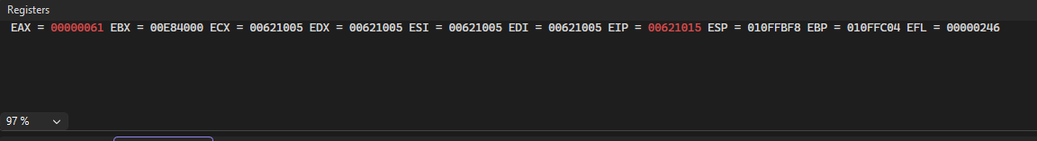
Task no 02:
- Use OR instruction to convert a binary digit to ASCII digit. Hint:
0 = 0 0 0 0 0 0 0 0 1 = 0 0 0 0 0 0 0 1 binary digits
‘0’ = 0 0 1 1 0 0 0 0 '1' = 0 0 1 1 0 0 0 1 ascii digits

Program:

.686p
.MODEL flat, stdcall
.code
main PROC
mov al, 00000001b
OR al, 00110001b
main endp
end main

Output:
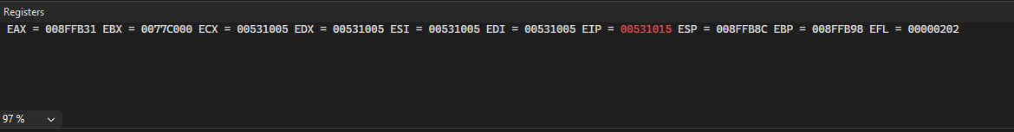

- Exercise:

1. Write a program to find the first negative value in an array.
2. Implement following block-structured IF statements in assembly;
a.
if( var1 == var2 )
X = 1;
else
X = 2;

b. Treat the following variables as unsigned;
if( ebx <= ecx )
{
eax = 5;
edx = 6;
}

c. Treat the following variables as signed;
if (var1 <= var2) {
var3 = 10;
}
else {
var3 = 6;
var4 = 7;
}

d. Compound expression with logical AND;
if ((al > bl) && (bl > cl)) {X = 1;}

e. While loop
while( eax < ebx) { eax = eax + 1; }

Code:
.386p
.model flat,stdcall
.code

main PROC

mov eax,4
mov ebx, 5

cmp eax,ebx
je equal

equal:
mov eax ,5
mov ebx , 7

main endp
end main

Output:

Code no 02:

.686p
.MODEL flat, stdcall
.code
main PROC
mov eax,5
mov ebx,10
cmp eax,ebx
jne n_e

equal:
mov eax,6
n_e:
mov ebx,2
main endp
end main

Output:

Code no 03:

.686
.MODEL flat, stdcall
.data
.code
main PROC
mov eax,0
mov ebx,10

L1:
cmp eax,ebx

jnl L1

endloop:

add eax,1

main endp
end main

Output:

